# Решение

Соединим все таблицы:

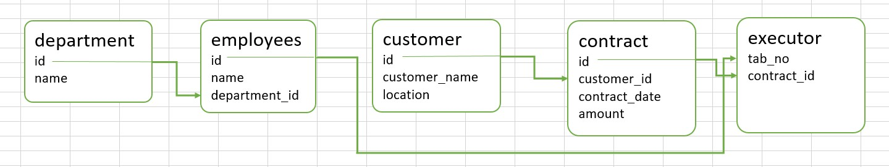

SELECT * FROM Executor ex

JOIN Employees em ON em.id = ex.tab_no

JOIN Department d ON d.id = em.department_id

JOIN Contract co ON co.id = ex.contract_id

JOIN Customer cu ON cu.id = co.Customer_id

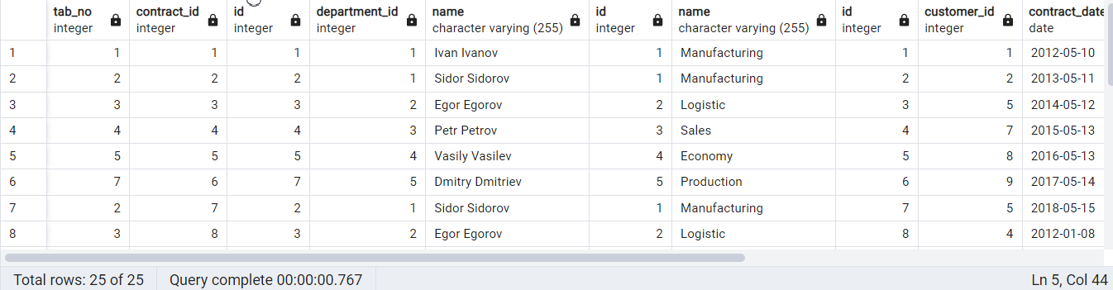

• Найти информацию о всех контрактах, связанных с сотрудниками департамента «Logistic». Вывести: contract_id, employee_name

SELECT ex.contract_id, em.name, d.name FROM Executor ex

JOIN Employees em ON em.id = ex.tab_no

JOIN Department d ON d.id = em.department_id

JOIN Contract co ON co.id = ex.contract_id

JOIN Customer cu ON cu.id = co.Customer_id

WHERE d.name = (SELECT name FROM Department WHERE name = 'Logistic')

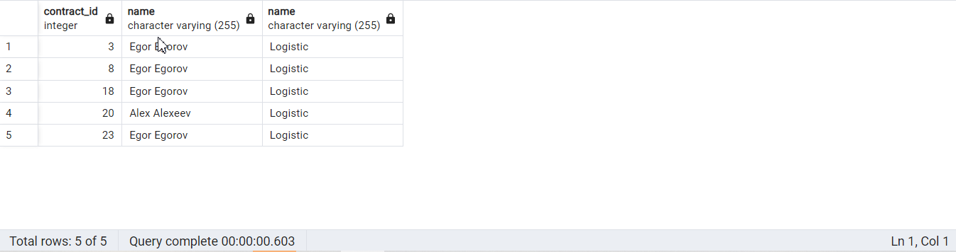

• Найти среднюю стоимость контрактов, заключенных сотрудником Ivan Ivanov. Вывести: среднее значение amount

SELECT em.name, ROUND(AVG(co.amount),2) FROM Employees em

JOIN Executor ex ON ex.tab_no = em.id

JOIN Department d ON d.id = em.department_id

JOIN Contract co ON co.id = ex.contract_id

JOIN Customer cu ON cu.id = co.Customer_id

WHERE em.name = (SELECT name FROM Employees WHERE name = 'Ivan Ivanov')

Group by em.name

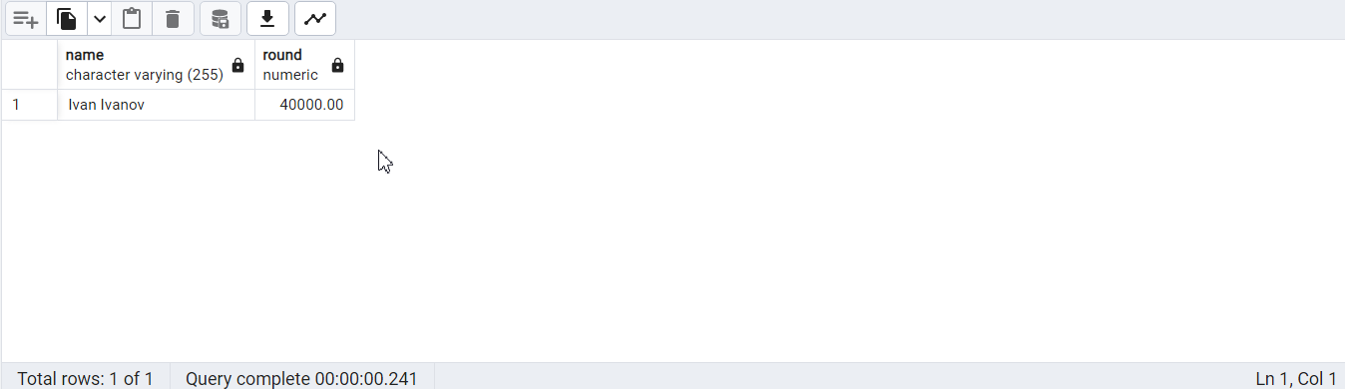

• Найти самую часто встречающуюся локации среди всех заказчиков. Вывести: location, count

SELECT count(cu.customer_name), cu.location FROM Executor ex

JOIN Employees em ON em.id = ex.tab_no

JOIN Contract co ON co.id = ex.contract_id

JOIN Customer cu ON cu.id = co.Customer_id

Group by cu.location

order by count(cu.customer_name)

desc

limit 1

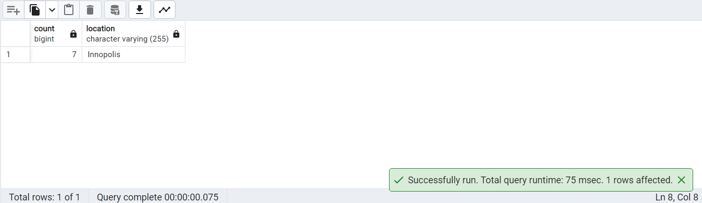

или иначе

SELECT count(cu.customer_name), cu.location FROM Executor ex

JOIN Employees em ON em.id = ex.tab_no

JOIN Contract co ON co.id = ex.contract_id

JOIN Customer cu ON cu.id = co.Customer_id

Group by cu.location

HAVING count(cu.customer_name) =

(SELECT count(Customer.customer_name) FROM Executor

JOIN Employees ON Employees.id = Executor.tab_no

JOIN Contract ON Contract.id = Executor.contract_id

JOIN Customer ON Customer.id = Contract.Customer_id

GROUP BY Customer.location

ORDER BY count(Customer.customer_name)

DESC

LIMIT 1)

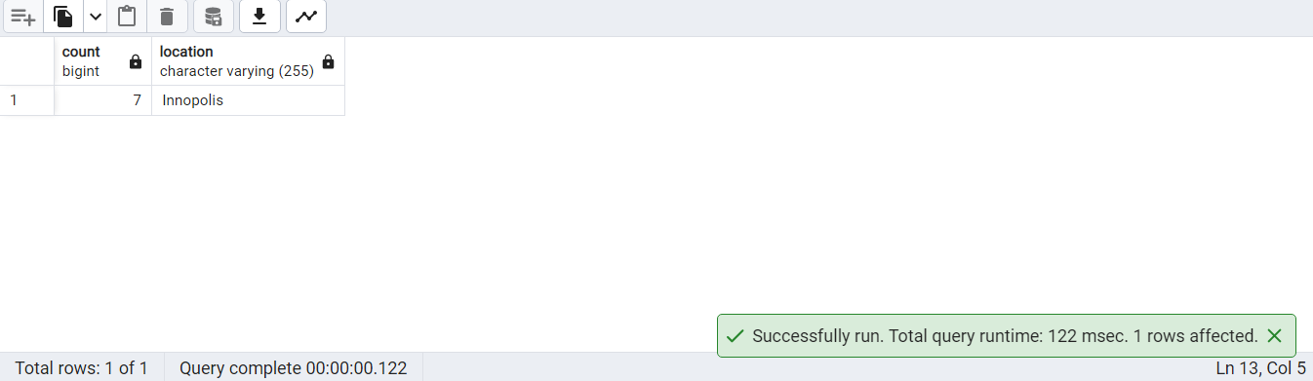

• Найти контракты одинаковой стоимости. Вывести count, amount

SELECT count(co.amount), co.amount FROM Executor ex

JOIN Employees em ON em.id = ex.tab_no

JOIN Department d ON d.id = em.department_id

JOIN Contract co ON co.id = ex.contract_id

JOIN Customer cu ON cu.id = co.customer_id

Group by co.amount

Having count(co.amount) >= 2

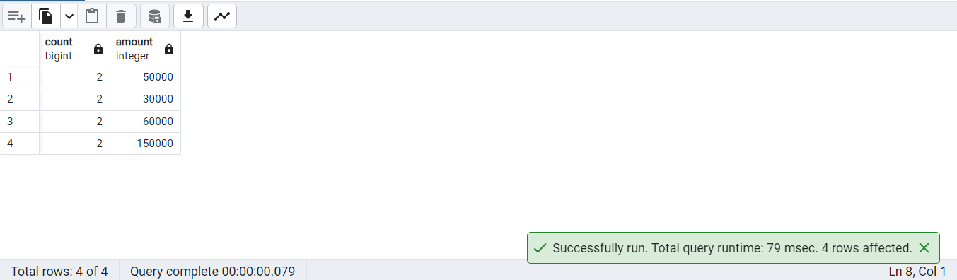

• Найти заказчика с наименьшей средней стоимостью контрактов. Вывести customer_name, среднее значение amount

SELECT cu.customer_name , ROUND(AVG(co.amount),2) FROM Employees em

JOIN Executor ex ON ex.tab_no = em.id

JOIN Contract co ON co.id = ex.contract_id

JOIN Customer cu ON cu.id = co.Customer_id

Group by cu.customer_name

ORDER BY ROUND(AVG(co.amount),2)

ASC

LIMIT 1

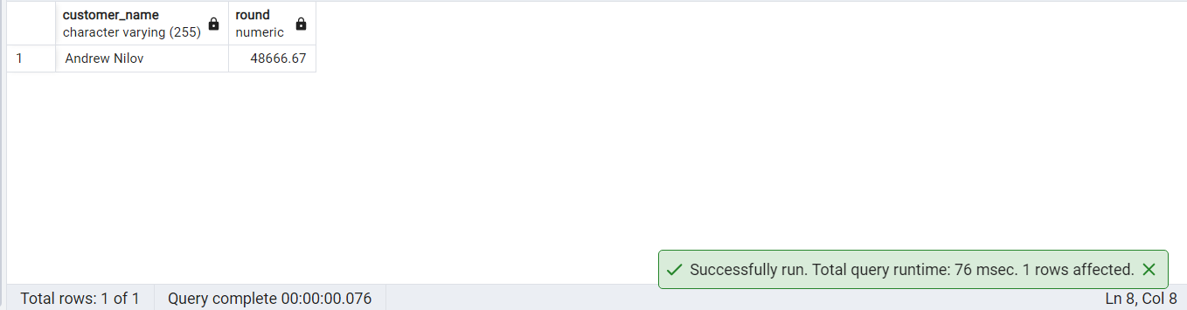

или иначе

SELECT cu.customer_name , ROUND(AVG(co.amount),2) FROM Employees em

JOIN Executor ex ON ex.tab_no = em.id

JOIN Contract co ON co.id = ex.contract_id

JOIN Customer cu ON cu.id = co.Customer_id

Group by cu.customer_name

HAVING ROUND(AVG(co.amount),2) =

(SELECT ROUND(AVG(contract.amount),2) FROM Employees

JOIN Executor ON Executor.tab_no = Employees.id

JOIN Contract ON Contract.id = Executor.contract_id

JOIN Customer ON Customer.id = Contract.Customer_id

GROUP BY Customer.customer_name

ORDER BY ROUND(AVG(contract.amount),2)

ASC

LIMIT 1)

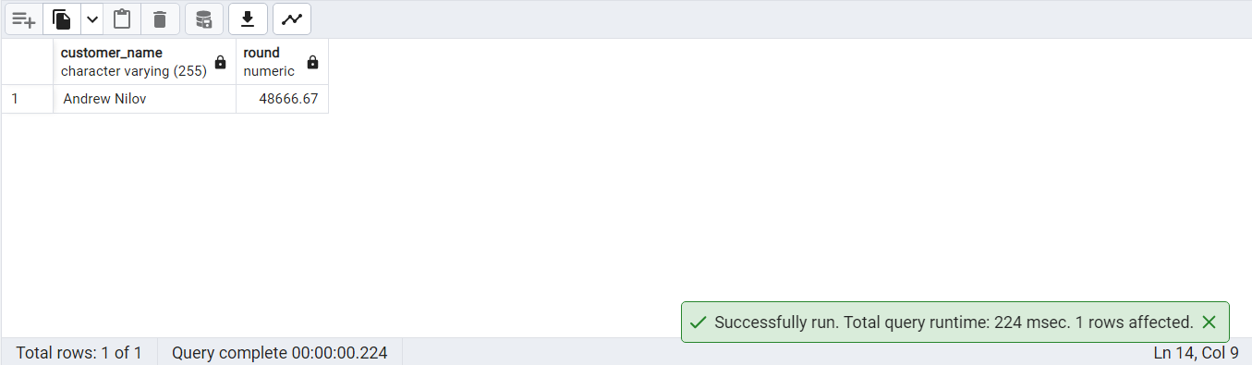

• Найти отдел, заключивший контрактов на наибольшую сумму. Вывести: department_name, sum

SELECT d.name, SUM(co.amount) FROM Executor ex

JOIN Employees em ON em.id = ex.tab_no

JOIN Department d ON d.id = em.department_id

JOIN Contract co ON co.id = ex.contract_id

Group by d.name

ORDER BY SUM(co.amount)

DESC

LIMIT 1

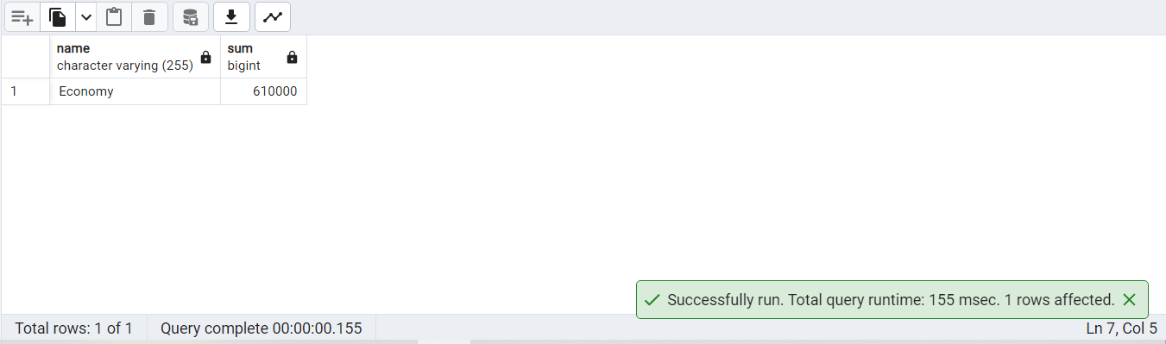

или иначе

SELECT d.name, SUM(co.amount) FROM Executor ex

JOIN Employees em ON em.id = ex.tab_no

JOIN Department d ON d.id = em.department_id

JOIN Contract co ON co.id = ex.contract_id

Group by d.name

HAVING SUM(co.amount) = (SELECT SUM(Contract.amount) FROM Executor

JOIN Employees ON Employees.id = Executor.tab_no

JOIN Department ON Department.id = Employees.department_id

JOIN Contract ON Contract.id = Executor.contract_id

GROUP BY Department.name

ORDER BY SUM(Contract.amount)

DESC

LIMIT 1)

